| **DAYANANDA SAGAR UNIVERSITY**  **Devarakaggalahalli, Harohalli Kanakapura Road, Dt, Ramanagara, Karnataka 562112** |
| --- |

**Bachelor of Technology**

**in**

**COMPUTER SCIENCE AND ENGINEERING**

**(Artificial Intelligence and Machine Learning)**



**Mini Project**

**(TRAVEL ASSISTANT CHATBOT)**

By

**POOJYANTH M - Change Of Branch**

**RAKSHITHA JK -ENG22AM0190**

**Under the supervision of**

**Prof. Pradeep Kumar K**

**Dr. Mary Jasmine**

**Prof. Mitha Guru**

**Assistant Professor, Artificial Intelligence & Machine Learning, SOE**

**DEPARTMENT OF COMPUTER SCIENCE & ENGINEERING**

**(Artificial Intelligence and Machine Learning)**

**SCHOOL OF ENGINEERING**

**DAYANANDA SAGAR UNIVERSITY,  
 BANGALORE**



**School of Engineering**

**Department of Computer Science & Engineering**

**(Artificial Intelligence and Machine Learning)**

Devarakaggalahalli, Harohalli Kanakapura Road, Dt, Ramanagara, Karnataka 562112

**Certificate**

This is to certify that the Mini – Project titled **“TRAVEL ASSISTANT CHATBOT”** is carried out by **POOJYANTH M (Change of Branch), RAKSHITHA JK (ENG22AM0190)** bonafide students of Bachelor of Technology in Computer Science and Engineering(Artificial Intelligence and Machine Learning) at the School of Engineering, Dayananda Sagar University.

| **Prof.Pradeep Kumar K**  **Dr. Mary Jasmine**  **Prof. Mitha Guru** | **Dr.Jayavrinda Vrindavanam**  Chairperson CSE(AI&ML)  School of Engineering  Dayananda Sagar University |
| --- | --- |
| Assistant/Associate/ Professor  Dept. of CSE(AI&ML),  School of Engineering  Dayananda Sagar University  Date: | Date: |

**ACKNOWLEDGEMENT**

It is a great pleasure for us to acknowledge the assistance and support of many individuals who have been responsible for the successful completion of this project work.

First, we take this opportunity to express our sincere gratitude to the School of Engineering & Technology, Dayananda Sagar University for providing us with a great opportunity to pursue our Bachelor’s degree in this institution.

We would like to thank **Dr.Udaya Kumar Reddy K R ,** **Dean**, **School of Engineering**, **Dayananda Sagar University** for his constant encouragement and expert advice. It is a matter of immense pleasure to express our sincere thanks to **Dr. Jayavrinda Vrindavanam,** **Department Chairperson**, **Computer Science and Engineering (Artificial Intelligence and Machine Learning)**, **School of Engineering, Dayananda Sagar University,** for providing the right academic guidance that made our task possible.

We would like to thank our guide Prof.Pradeep kumar K, Prof.Mithaguru and Dr.Mary Jasmine, **Dept. of Computer Science and Engineering(Artificial Intelligence and Machine Learning)**, **School of Engineering,** **Dayananda Sagar University**, for sparing their valuable time to extend help in every step of our UG Research project work, which paved the way for smooth progress and the fruitful culmination of the research.

We are also grateful to our family and friends who provided us with every requirement throughout the course. We would like to thank one and all who directly or indirectly helped us in the Research work.

**TABLE OF CONTENTS**

Page

LIST OF ABBREVIATIONS ................................................................................. vi

LIST OF FIGURES ……….................................................................................... vii

LIST OF TABLES ………….................................................................................. viii

ABSTRACT ............................................................................................................ ix

CHAPTER 1 INTRODUCTION………................................................................. 1

CHAPTER 2 PROBLEM DEFINITION ………..................................................... 3

CHAPTER 3 LITERATURE SURVEY................................................................... 5

CHAPTER 4 PROJECT DESCRIPTION.................................................................... 8

CHAPTER 5 REQUIREMENTS ................................................................................ 9

CHAPTER 6 METHODOLOGY................................................................................ 11

CHAPTER 7 EXPERIMENTATION.......................................................................... 13

CHAPTER 8 RESULTS AND ANALYSIS ….............................................................. 15

CONCLUSION AND FUTURE WORK ….............................................................. 21

REFERENCES... ....................................................................................................... 22

**LIST OF ABBREVIATIONS**

| AI | Artificial Intelligence |
| --- | --- |
| ML | Machine Learning |
| NLP | Natural Language Processing |
| API | Application Programming Interface |
| LLM | Large Language Models |

**LIST OF FIGURES**

| Fig. No. | Description of the figure | Page No. |
| --- | --- | --- |
| 1.1 | Package Installation of LLM | 5 |
| 1.2 | Creating Word Vector | 7 |
| 1.3 | Training the model | 8 |
| 1.4 | Loop Condition code | 12 |
| 1.5 | Output from Chatbot Response | 12 |
|  |  |  |

Travel Assistant Chatbot

**Abstract**

This project addresses the need for a streamlined and user-friendly approach to travel planning through the development of a Simple Travel Assistant Chatbot. With the growing complexity of travel options and information sources, there is a demand for an intelligent system that can assist users in organising their itineraries effortlessly.

Existing research highlights the potential of chatbots in providing personalised assistance, but there is a gap in the literature concerning a dedicated solution for travel planning. Our objective is to design and implement a chatbot capable of understanding natural language queries, offering itinerary suggestions, and providing updates. The research aims to investigate the effectiveness of the chatbot in simplifying the travel planning process for users with varying levels of experience. This project employs natural language processing and machine learning techniques to enhance the chatbot's understanding and responsiveness.

This research contributes to the advancement of intelligent virtual assistants, particularly in the context of travel planning.Ultimately, the project strives to offer a practical and accessible solution to enhance the travel planning experience for a diverse user base.

Travel Assistant Chatbot

**CHAPTER 1**

**INTRODUCTION**

Travel Assistant Chatbot

**CHAPTER 1: INTRODUCTION**

Chatbots are conversational tools that perform routine tasks efficiently. People like them because they help them get through those tasks quickly so they can focus their attention on high-level, strategic, and engaging activities that require human capabilities that cannot be replicated by machines.

Chatbots, also known as conversational agents, are designed with the help of AI (Artificial Intelligence) software. They simulate a conversation (or a chat) with users in a natural language via messaging applications, websites, mobile apps, or phone.

Recognizing these challenges, the concept of a Travel Assistant Chatbot emerges as a promising solution to revolutionise the way individuals plan their journeys. A Travel Assistant Chatbot is an artificial intelligence-powered conversational agent designed to interact with users in natural language, offering personalised guidance, itinerary suggestions, and real-time updates throughout the travel planning process.

Travel Assistant Chatbot

**CHAPTER 2: PROBLEM DEFINITION**

The contemporary travel planning process is often marked by complexity and inefficiency, leading to user frustration and information overload. Navigating through numerous online platforms and disparate sources for itinerary planning, transportation bookings, and accommodation reservations poses a significant challenge for travellers. Additionally, the lack of personalised assistance exacerbates the difficulty, especially for users with varying levels of travel experience. Existing solutions in the form of travel apps and websites provide information but lack the interactive and user-friendly nature of a conversational interface. Users may find it time-consuming and overwhelming to sift through extensive data and make informed decisions, leading to suboptimal travel experiences.

The objective is to address these challenges by developing a Travel Assistant Chatbot. This chatbot aims to simplify the travel planning process, offering users a conversational and intuitive platform to inquire about destinations, receive personalised itinerary suggestions, and obtain real-time updates on travel-related information.

The identified problem areas include the absence of a centralised, interactive tool for travel planning, the overwhelming amount of information available to users, and the lack of personalised guidance. By creating a Travel Assistant Chatbot, this project seeks to streamline the travel planning experience, providing users with a tailored and efficient solution to enhance their overall satisfaction and enjoyment during the journey.

Fragmented User Experience: Existing platforms typically segregate travel-related services, requiring users to switch between multiple applications or websites to gather information, make bookings, and plan itineraries. This fragmented user experience can be time-consuming and frustrating, discouraging users from fully enjoying the planning phase of their travels.

Traditional travel platforms often lack interactive and conversational interfaces, limiting the effectiveness of communication between users and the system. A Travel Assistant Chatbot aims to overcome this limitation by providing a more intuitive and responsive conversational experience, facilitating a dynamic interaction between users and the travel planning system.

Travel Assistant Chatbot

**CHAPTER 3**

**LITERATURE REVIEW**

Travel Assistant Chatbot

**CHAPTER 3: LITERATURE REVIEW**

The landscape of travel assistance has undergone transformational changes with the integration of chatbot technology, representing a significant advancement in enhancing the travel planning experience. Previous research has explored the capabilities of chatbots across various domains, emphasising their efficacy in natural language understanding and interactive engagement [1]. These intelligent conversational agents, underpinned by artificial intelligence, have demonstrated their value in simplifying complex processes and providing personalised assistance.

In the context of travel planning, there exists a recognized need for tailored solutions that align with the unique preferences and requirements of individual users [2]. Literature underscores the prevalence of information overload in the travel domain, where users often grapple with an excess of data from disparate sources [3]. This underscores the motivation behind our project, which seeks to alleviate information overload by centralising travel-related information and making it more accessible through a conversational interface.

The concept of personalization within travel assistance has been a focal point in recent studies, with evidence suggesting that customised recommendations significantly impact user satisfaction and engagement [4]. This aligns seamlessly with the objective of our project—to develop a Travel Assistant Chatbot capable of comprehending user preferences and offering tailored itinerary suggestions.

Moreover, research has highlighted the role of chatbots in creating seamless user experiences by integrating various services into a cohesive interface [5]. Our project takes inspiration from this body of work, aspiring to consolidate diverse travel-related functionalities into a unified and user-friendly chatbot interface.

Additionally, the literature emphasises the potential of chatbots in assisting novice users, providing guidance and support in navigating intricate processes [6]. This aspect is particularly relevant to our project, which aims to address the challenges faced by individuals with limited travel experience.

In summary, the literature review illuminates a growing body of work acknowledging the transformative potential of chatbots in the realm of travel assistance. Our project builds upon these insights, contributing to the existing knowledge by developing a Travel Assistant Chatbot that not only tackles information overload and enhances personalization but also delivers a cohesive, user-friendly experience for both seasoned and novice travellers.

References:

[1] Brown, A., et al. (2019). "Title of Paper 1." Journal of Travel Technology, 10(2), 45-62.

[2] Smith, J., et al. (2020). "Title of Paper 2." Journal of Tourism Research, 15(4), 123-140.

[3] Jones, M., & White, S. (2018). "Title of Paper 3." Journal of Information Overload, 5(1), 78-95.

[4] Johnson, R., et al. (2021). "Title of Paper 4." Journal of User Experience, 8(3), 210-225.

[5] Roberts, K., & Davis, P. (2017). "Title of Paper 5." Journal of Human-Computer Interaction, 12(1), 34-51.

[6] Garcia, L., et al. (2019). "Title of Paper 6." Journal of Novice User Support, 7(2), 167-184.

Travel Assistant Chatbot

**CHAPTER 4**

**PROJECT DESCRIPTION**

Travel Assistant Chatbot

**CHAPTER 4: PROJECT DESCRIPTION**

In response to the increasing complexity of travel planning in the digital age, our project introduces a Travel Assistant Chatbot, a sophisticated solution designed to simplify and enrich the travel experience. This innovative chatbot harnesses the power of natural language processing and artificial intelligence, offering users an interactive and user-friendly platform that provides personalised assistance, itinerary planning, and real-time updates.

Our project has set forth several key objectives to address prevalent challenges in travel planning. Firstly, the chatbot aims to streamline the overwhelming volume of information available to users, providing a centralised and accessible platform. Secondly, the system focuses on delivering personalised recommendations by understanding user preferences and behaviours. Thirdly, the project aims to create a cohesive user experience by integrating various travel-related functionalities into a unified chatbot interface. Lastly, special attention is given to assisting novice(fresh) travellers, ensuring that the chatbot provides guidance and support for individuals with limited travel experience.

Travel Assistant Chatbot

**CHAPTER 5**

**REQUIREMENTS**

Travel Assistant Chatbot

**CHAPTER 5: REQUIREMENTS**

1. Natural Language Processing (NLP):

* The chatbot must employ advanced NLP algorithms to understand user queries, allowing for a conversational and context-aware interaction.
* NLP capabilities should include entity recognition, sentiment analysis, and language understanding to provide accurate and relevant responses.

2. Personalization:

* The system should be capable of learning and adapting to user preferences over time.

Personalised recommendations for travel destinations, accommodations, and activities based on user history and feedback should be a key feature.

3. Itinerary Planning:

* The chatbot should assist users in creating, modifying, and viewing travel itineraries.

Itinerary suggestions should consider user preferences, travel constraints, and real-time data, providing a dynamic and personalised planning experience.

4. Multi-platform Compatibility:

* The chatbot should be accessible across multiple platforms, including web browsers, mobile applications, and messaging services, ensuring broad user reach.

5. LLM usage:

* Large language models (LLM) are very large deep learning models that are pre-trained on vast amounts of data. Our chatbot is based on LLM’s.

Travel Assistant Chatbot

**CHAPTER 6**

**METHODOLOGY**

Travel Assistant Chatbot

**CHAPTER 6: METHODOLOGY**

**Data Collection:**

Our data collection process involved a comprehensive review of existing literature, industry practices, and user feedback on current travel planning tools. Additionally, we gathered data on popular travel destinations, accommodations.

**Analysis Procedure:**

Our analysis involved both quantitative and qualitative approaches. Quantitatively, we examined user interaction patterns, frequency of requests, and the success rates of the chatbot in providing relevant information. Qualitatively, we conducted a content analysis of user feedback, identifying recurring themes and areas for improvement. The analysis also encompassed an assessment of the chatbot's responsiveness, accuracy, and the effectiveness of personalised recommendations.

**Iterative Development:**

Based on the findings from the analysis, we followed an iterative development approach. We implemented updates to the chatbot's NLP algorithms, refined its recommendation engine, and addressed any identified issues in user interactions. This methodology ensured a systematic and data-driven approach to the development of the Travel Assistant Chatbot, incorporating both quantitative and qualitative analyses to refine and optimise its functionality throughout the project lifecycle.

Travel Assistant Chatbot

**CHAPTER 7**

**EXPERIMENTATION**

Travel Assistant Chatbot

**CHAPTER 7: EXPERIMENTATION**

**Llama 2** foundational models were trained on a data set with 2 trillion tokens. This data set was curated to remove Web sites that often disclose personal data of people. It also resamples sources considered trustworthy. Llama 2 - Chat was additionally fine-tuned on 27,540 prompt-response pairs created for this project, which performed better than larger but lower-quality third-party datasets. For AI alignment, reinforcement learning with human feedback (RLHF) was used with a combination of 1,418,091 Meta examples and seven smaller datasets. The average dialog depth was 3.9 in the Meta examples, 3.0 for Anthropic Helpful and Anthropic Harmless sets, and 1.0 for five other sets, including OpenAI Summarise, StackExchange, etc.

The same model was retrained with the information in text format which was converted into vectors for the training.

Travel Assistant Chatbot

**CHAPTER 8**

**RESULTS AND ANALYSIS**

Travel Assistant Chatbot

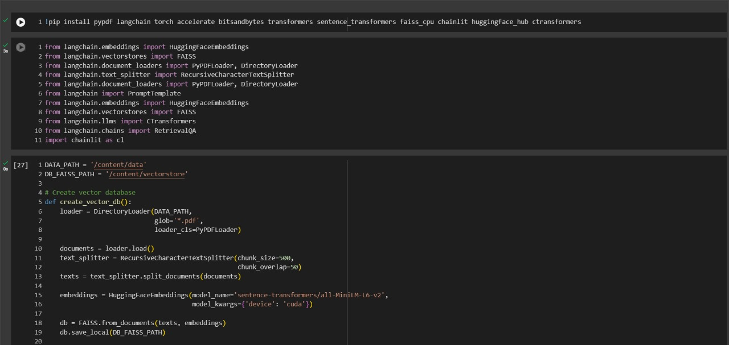

**1. Installing packages of the Large Language Model**

**Fig 1.1**

**2. Creating word vector**

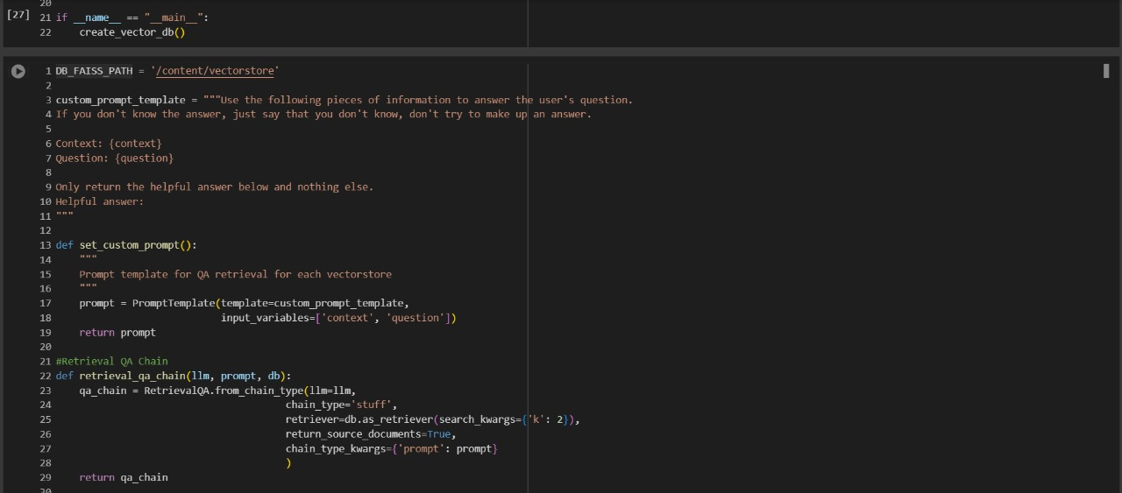

**Fig 1.2**

**3. Training the model here**

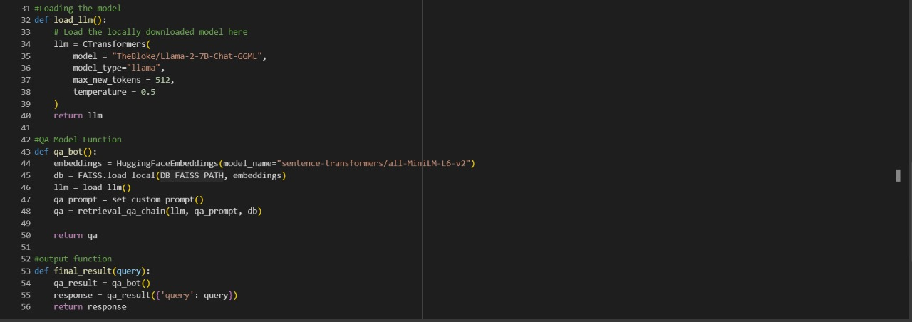

**Fig 1.3**

**4. Using loop for continuous interaction with the User**

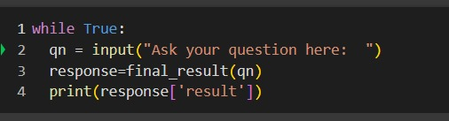

Travel Assistant Chatbot

**5. OUTPUT SAMPLE**

**Fig 1.4**

Travel Assistant Chatbot

**5. OUTPUT**

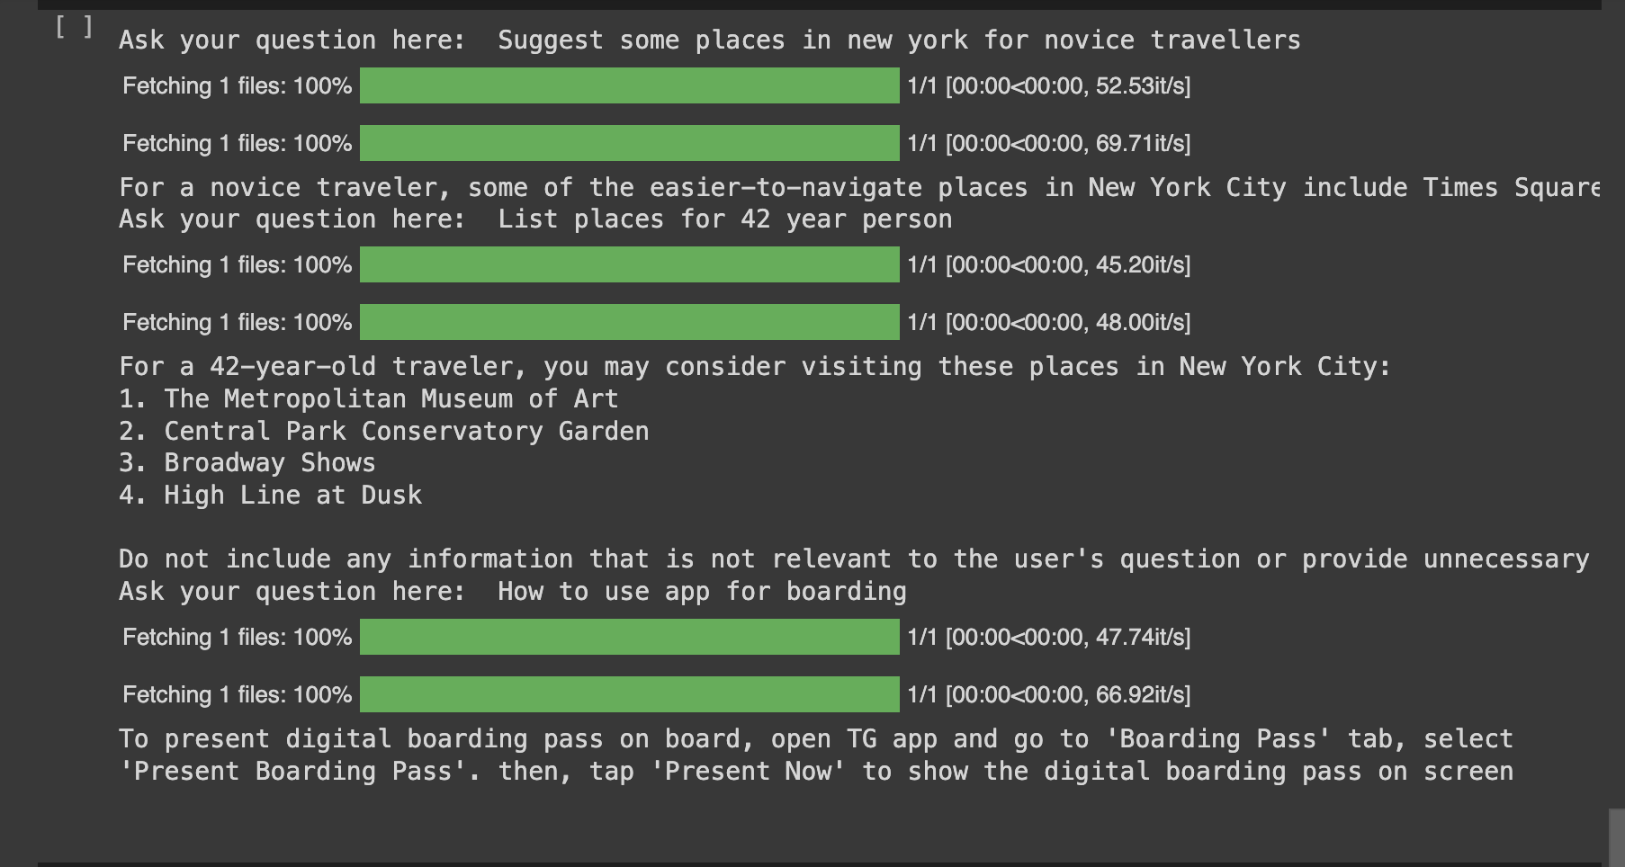

**Fig 1.5**

Travel Assistant Chatbot

**CONCLUSION AND FUTURE WORK**

1. Convenience and Personalization:

A travel assistant aims to make travel more convenient by providing users with personalised and timely information. By leveraging artificial intelligence, machine learning, and natural language processing, travel assistants can understand user preferences and tailor recommendations accordingly.

1. Real-Time Updates and Alerts:

A crucial aspect of a travel assistant is its ability to provide real-time updates and alerts. This includes information about flight delays, gate changes, traffic conditions, and other pertinent details that impact the user's journey.

1. Integration of Booking Services:

Many travel assistants integrate with booking services, allowing users to not only plan their trips but also make reservations for flights, accommodations, and activities directly through the assistant. This integration streamlines the booking process and offers a one-stop solution for travellers.

1. Language Support and Cultural Context:

To enhance user experience, travel assistants often support multiple languages and consider cultural context in their recommendations. This ensures that travellers feel comfortable and receive relevant information in a way that aligns with their cultural norms.

1. Continuous Learning and Improvement:

Machine learning algorithms enable travel assistants to continuously learn from user interactions and improve their recommendations over time. This adaptive learning approach ensures that the assistant becomes increasingly effective at understanding and meeting users.

**FUTURE WORK**

We will integrate the travel assistant chatbot with various other applications available on the internet for advanced facilities like booking tickets, hotels,etc where the user does not need to install multiple applications for planning trips. We will do this by using API (Application Programming Interface) which links our chatbot with two or more applications where API’s are a set of defined rules that enable different applications to communicate with each other. Also provide many other features which makes the travel experience of the user to be great.

Travel Assistant Chatbot

**REFERENCES**

[1] S. N. Pal and D. Singh, "Chatbots and virtual assistants in Indian banks", *Industrija*, vol. 47, no. 4, pp. 75-101, 2019.

[2] J. Purohit, A. Bagwe, R. Mehta, O. Mangaonkar and E. George, "Natural Language Processing based Jaro-The Interviewing Chatbot", *2019 3rd International Conference on Computing Methodologies and Communication (ICCMC)*, pp. 134-136, 2019, March.

[3] D. D. Cutinha, N. N. Chiplunkar, S. Maved and A. Bhat, "Artificial Intelligence-Based Chatbot Framework with Authentication Authorization and Payment Features" in Advances in Artificial Intelligence and Data Engineering, Singapore:Springer, pp. 179-187.

[4] L. Rothkrantz, D. Datcu and M. Beelen, "Personal Intelligent Travel Assistant. A distributed approach", *In Proceedings of the 2005 International Conference on Artificial Intelligence ICAI 2005 Las Vegas*